Experiment 2 - Bus Ticket Booking System Prototype using Figma

Aim:
To design a simple prototype of a Bus Ticket Booking System using Figma.
Tool Used: Figma
Description:
The Bus Ticket Booking System prototype provides a simple and user-friendly interface for booking bus tickets. The prototype includes screens for searching buses, selecting seats, making payments, and viewing booking confirmations.
Screens Designed:
Home Screen
Search Bus Screen
Seat Selection Screen
Payment Screen
Booking Confirmation Screen
Workflow:
1. User enters source, destination, and travel date.
2. Available buses are displayed.
3. User selects a bus and chooses seats.
4. User enters payment details and completes the payment.
5. Booking confirmation with ticket details is displayed.
Features:
Bus Search
Seat Selection
Online Payment
Ticket Confirmation
Simple User Interface
Result:
The Bus Ticket Booking System prototype was successfully designed using Figma. The prototype demonstrates the complete ticket booking workflow with connected screens.

Output:
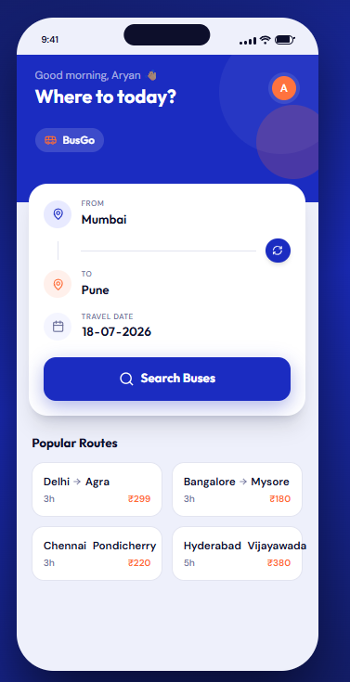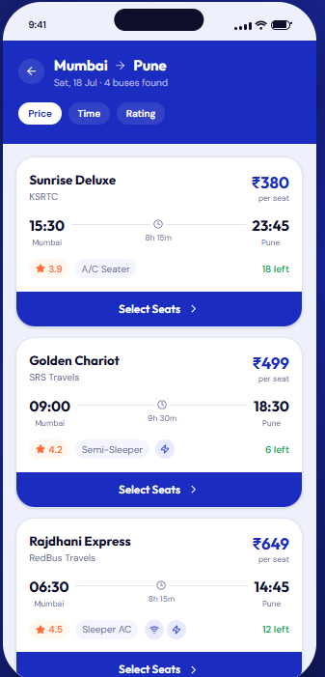

- Home page 2. Bus Search

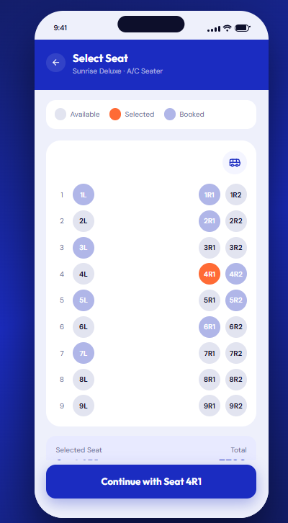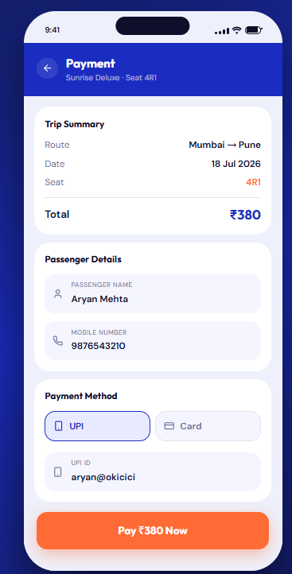
3. Seat Selection 4. Online Payment

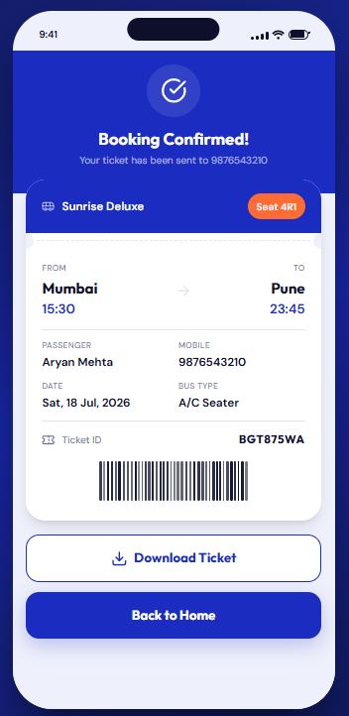
5. Ticket Confirmation

